Based on 2025 market trends, sustainability reports, and consumer reviews, the top natural and renewable energy products are focused on home electrification, AI-powered efficiency, and utilizing solar or geothermal energy to reduce grid dependency.

Here are 10 of the best-selling and highest-rated natural energy usage products in 2025:

1. **Smart Solar Heat Pump Water Heater:** Leading the market, these units (like those from Smart Solar) combine solar power with ultra-efficient heat pump technology, providing low-cost hot water by leveraging ambient air and sun.

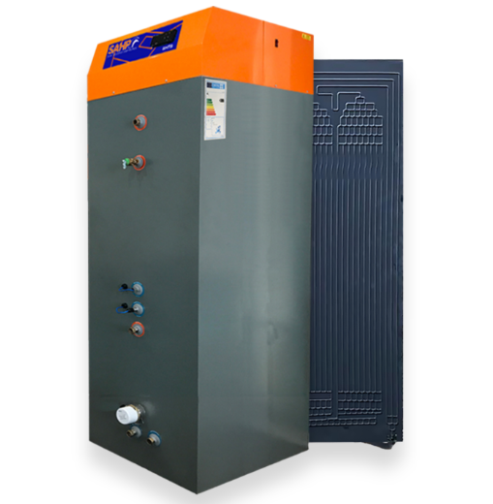

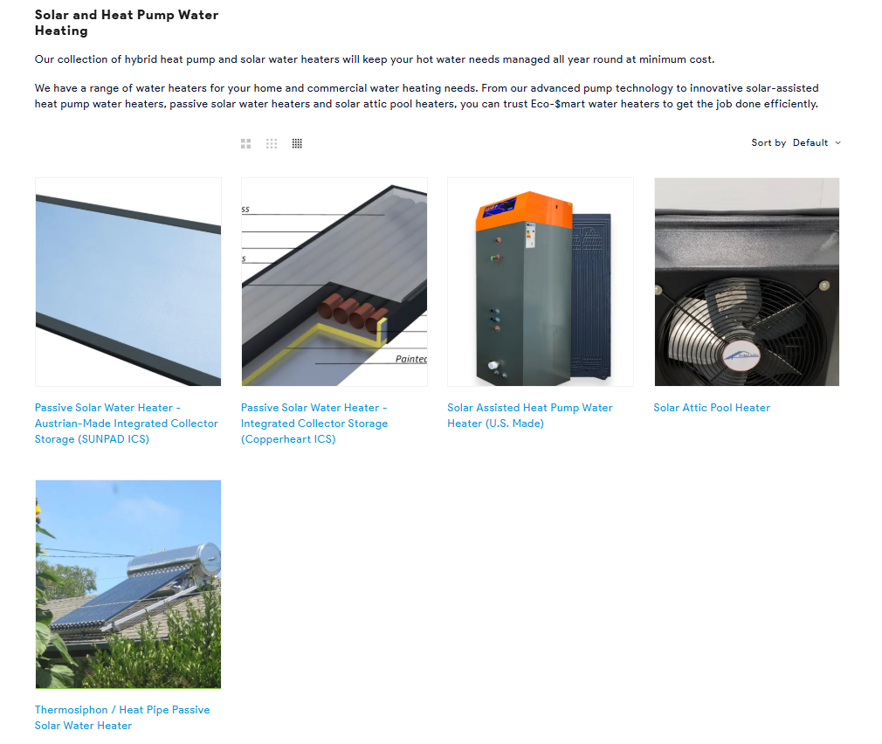

1. **Tesla Powerwall (and similar Home Battery Storage):** As a premier energy management system, it stores solar energy and automatically shifts usage away from peak grid hours, often reducing grid reliance by 70-90%.

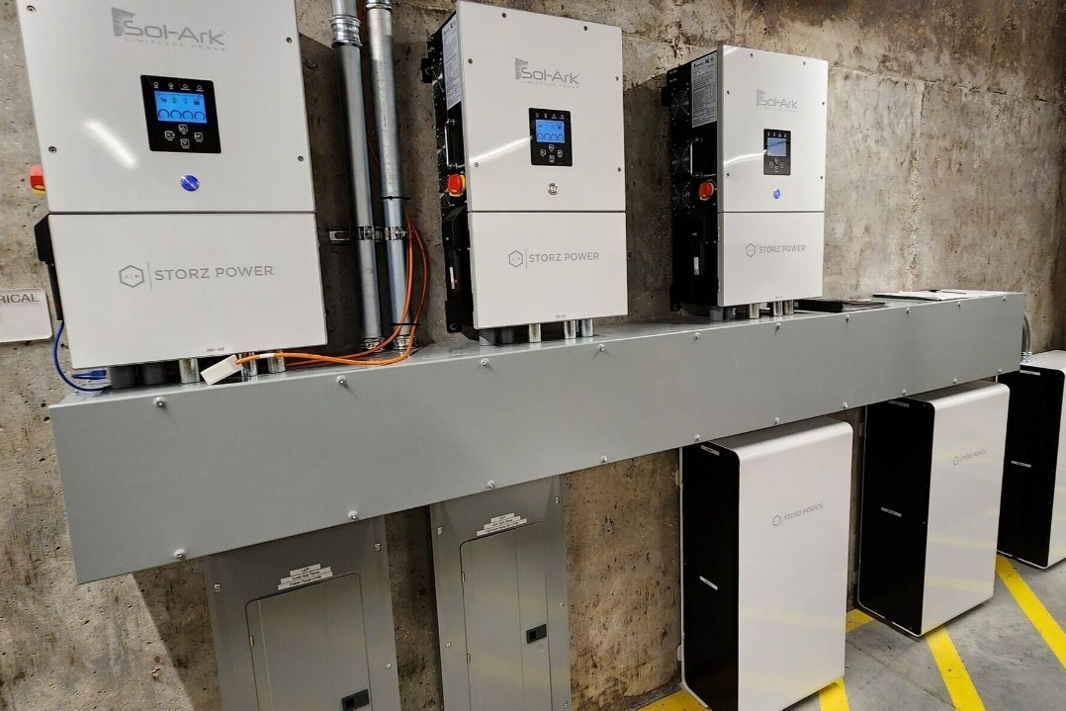

1. **Sense Home Energy Monitor:** This AI-powered device clamps into electrical panels to identify specific appliances, allowing users to track, in real-time, which devices are consuming the most energy to make informed saving decisions.

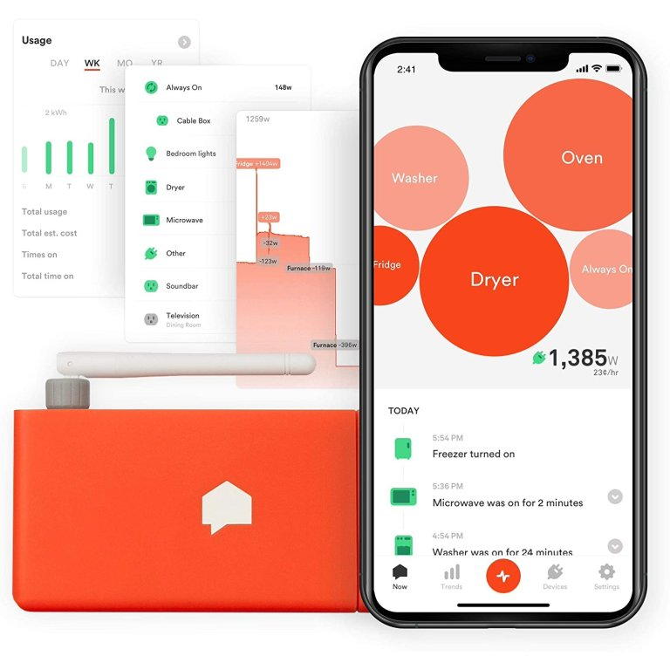

1. **Ecobee Smart Thermostat with eco+:** This device is a top choice for optimizing HVAC systems—which consume 40-50% of home energy—by automatically adjusting based on usage patterns and, crucially, participating in utility demand response programs.

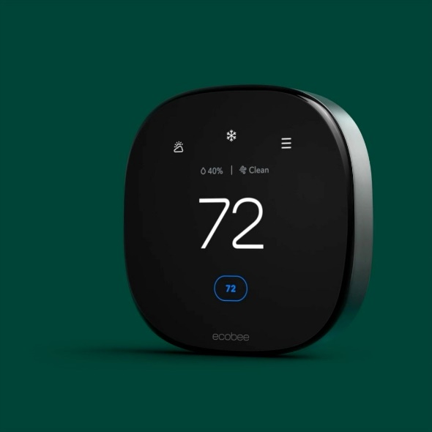

1. **GE Profile Smart Induction Cooktop:** Rated for high energy efficiency, induction technology is rapidly replacing gas. GE’s models use AI sensors to heat only the cookware, reducing wasted energy.  
   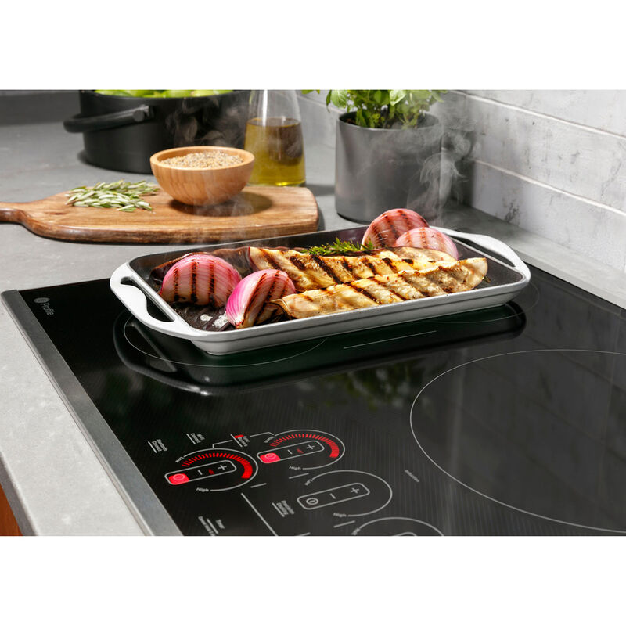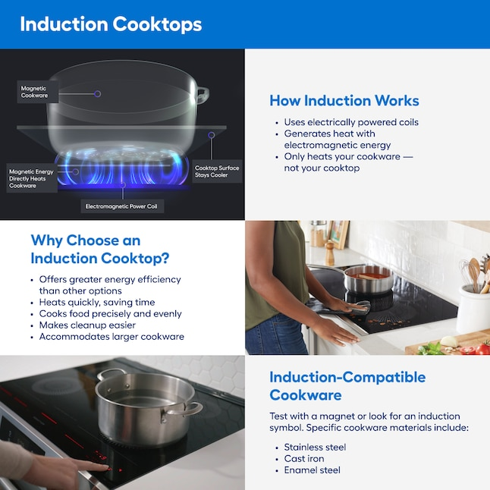
2. **EcoFlow AI Oasis Energy Management System:** Debuted at CES 2025, this system works with solar panels and battery storage, using AI to manage power needs based on, electricity rates, and weather patterns to maximize efficiency.

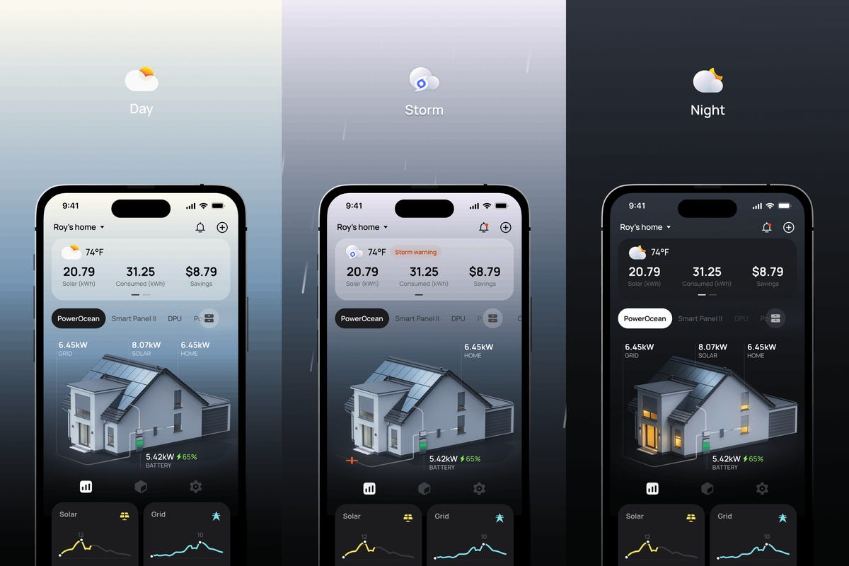

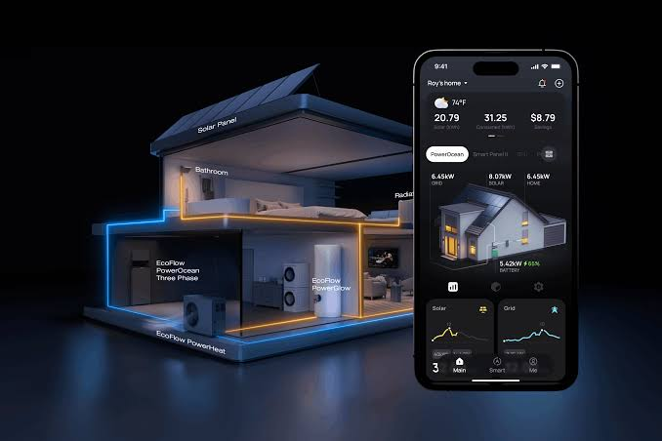

1. **Whole House Fans (e.g., from**[Wholehousefan.com](https://www.wholehousefan.com/blogs/wholehousefans/best-home-energy-management-systems)**):** A top choice for reducing cooling costs, these systems pull cool night air through the home and exhaust hot air, slashing AC usage by 50-90% during summer months.

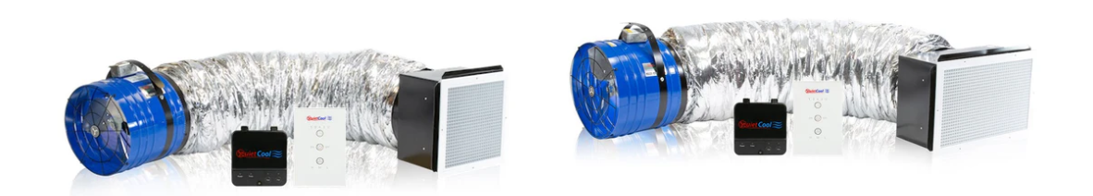

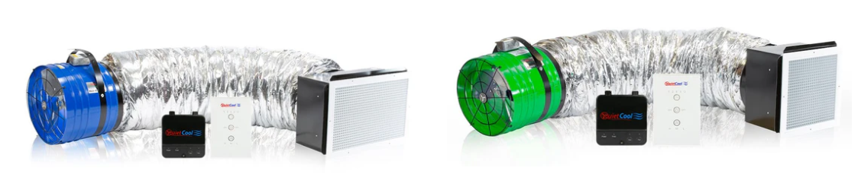

1. **Emporia Vue 3 Energy Monitor:** A highly rated, budget-friendly, and granular energy monitor that allows for circuit-level tracking, enabling homeowners to monitor high-power systems like heat pumps and EV chargers.

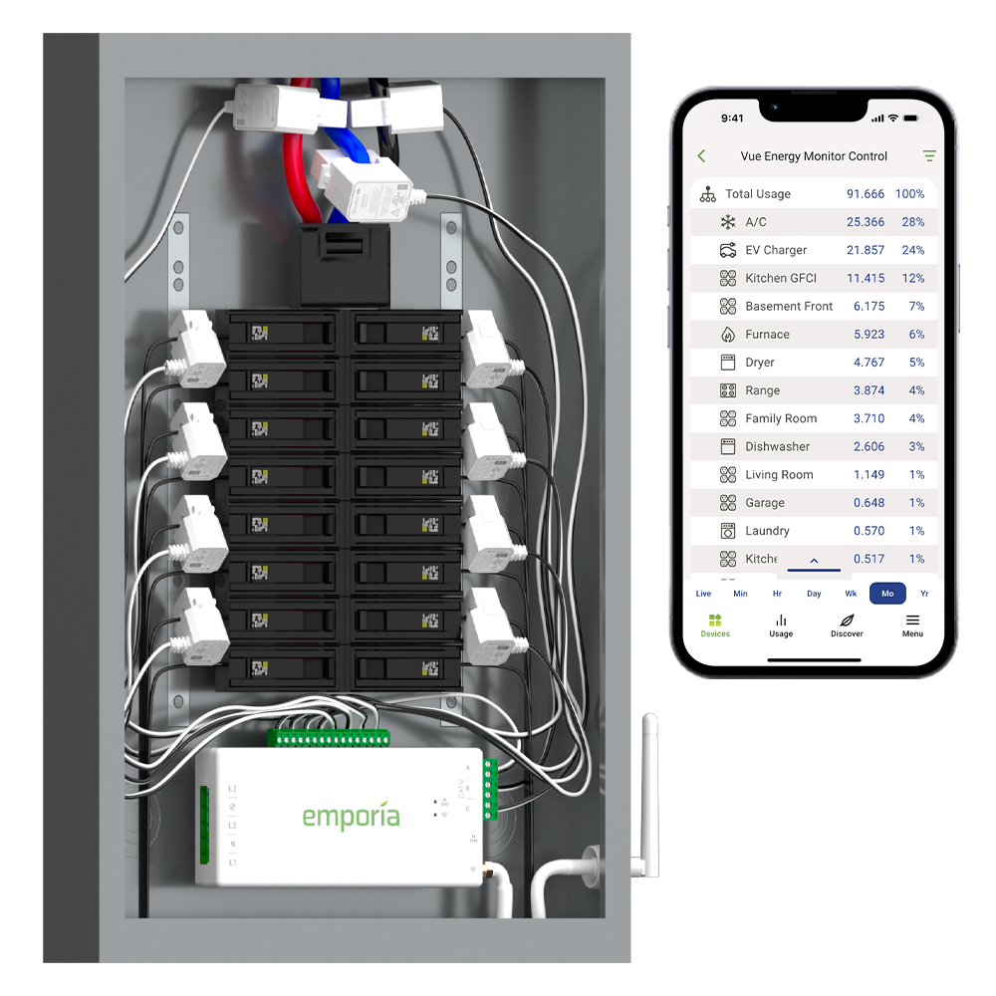

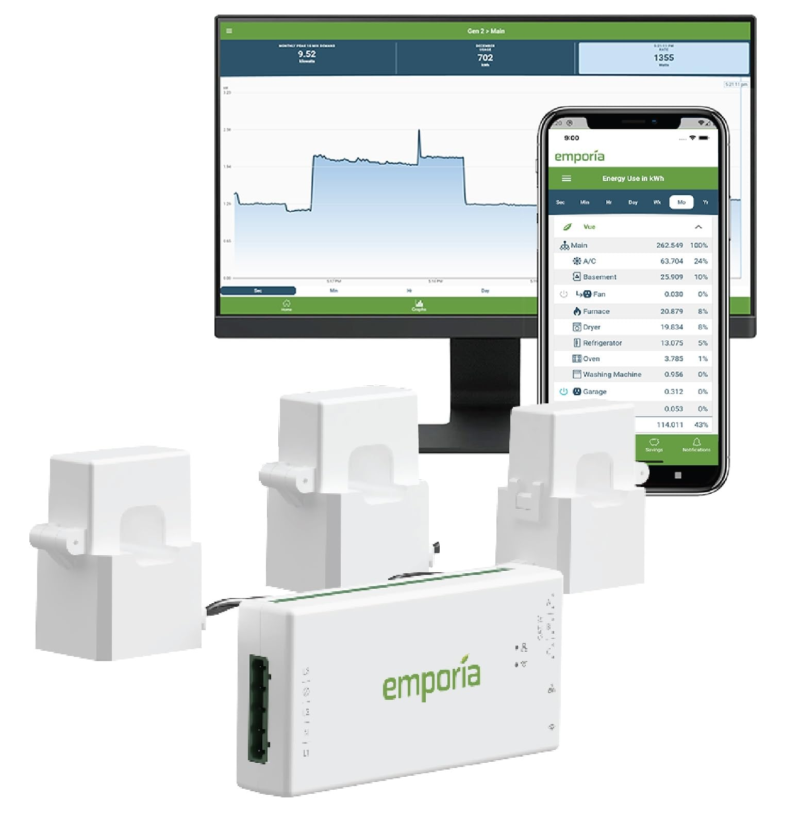

1. **High-Efficiency R-32 Refrigerant Dehumidifiers (e.g., Midea 50 Pint Cube):** Using the new R-32 refrigerant, these 2025 models are 8-12% more efficient than older units, delivering high-performance moisture removal with lower power consumption.

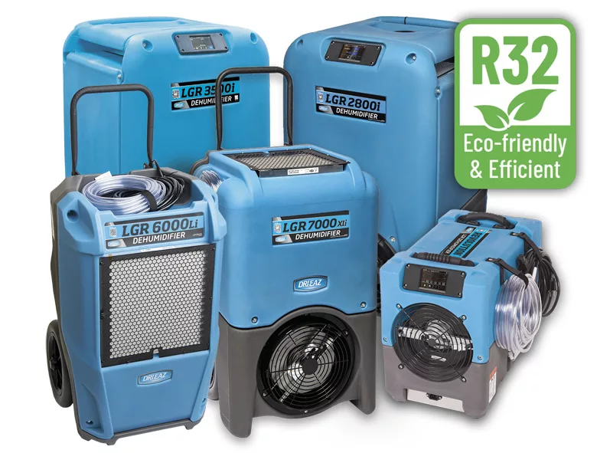

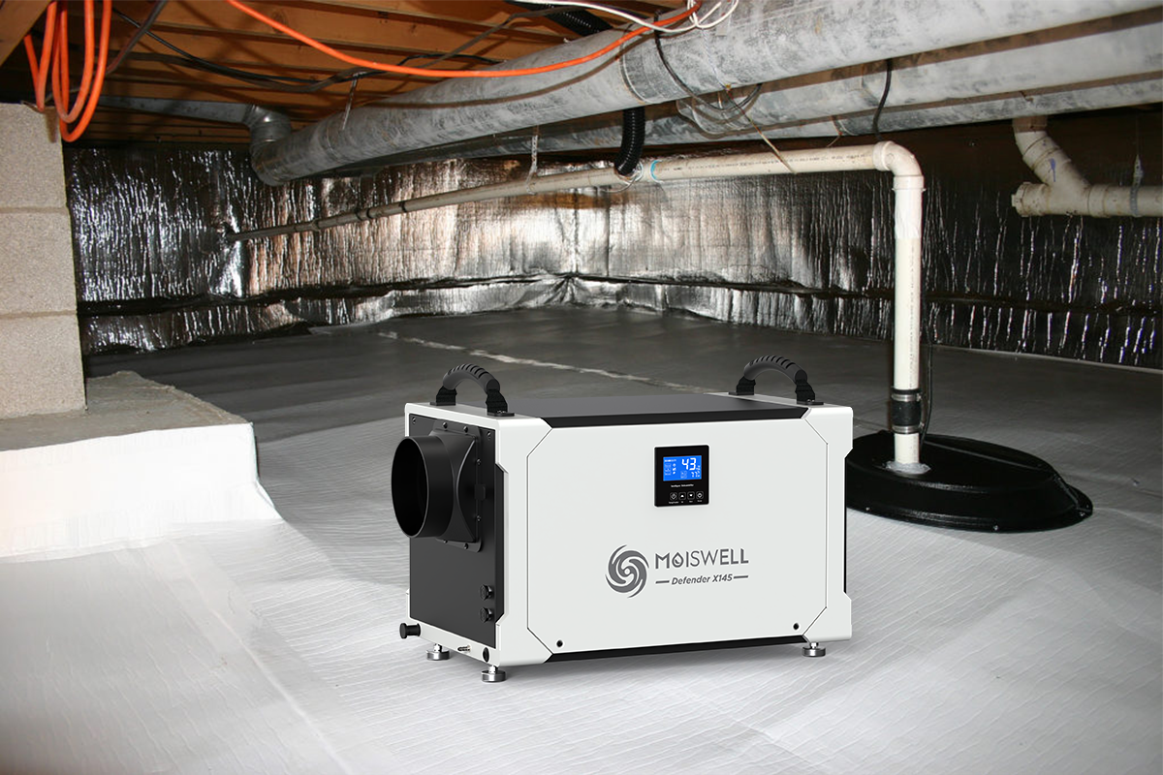

1. **Solar-Powered Outdoor Security & Lighting Devices:** These devices, such as motion lights and cameras, are popular for offering zero-cost, renewable energy operation for home security.

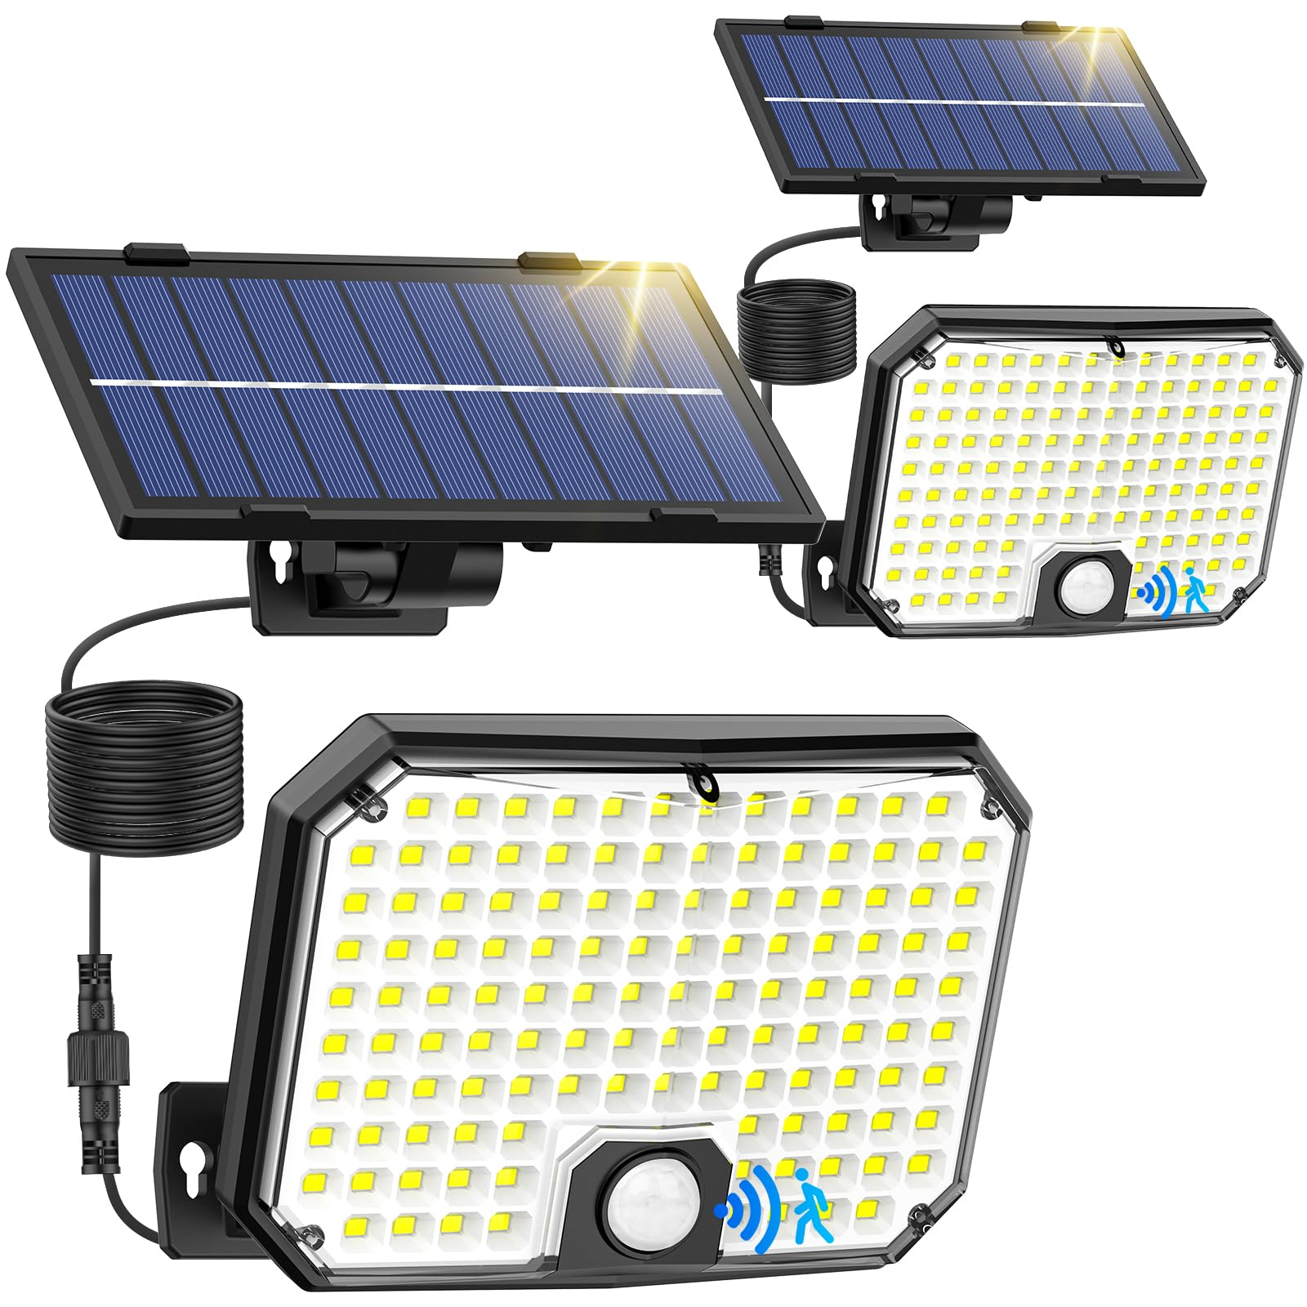

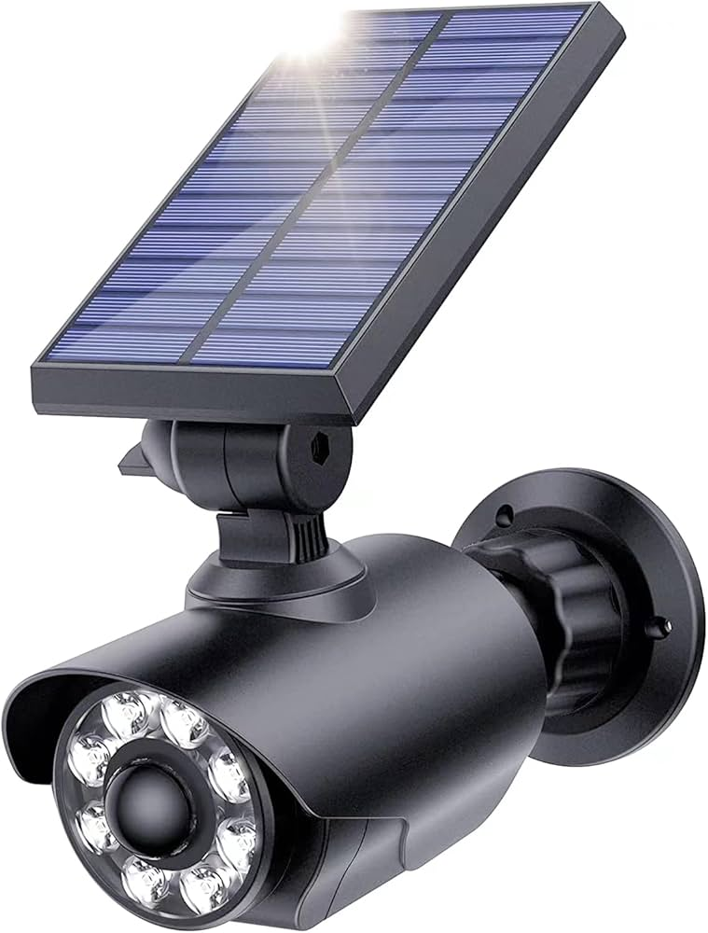

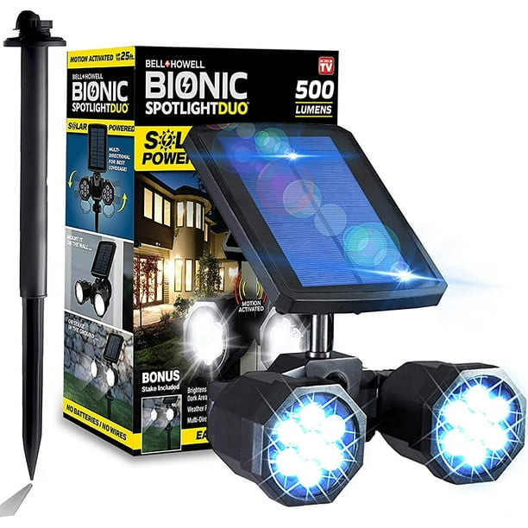

**Key 2025 Trends**

* **AI Integration:** Many products now use machine learning to automatically manage energy usage, such as adjusting when a dishwasher or dryer runs based on solar availability.
* **Heat Pump Technology:** Heat pumps are the dominant technology for heating, cooling, and water heating in 2025, supported by ENERGY STAR as the most efficient, 100% electric solution.
* **Solar Self-Consumption:** Solutions that help homeowners store and use their own generated solar power (like Tesla Powerwall or Bosch Energy Manager) are seeing massive adoption.